WEB TECHNOLOGY PROJECT – 3

Title: Advanced Password Strength Checker using HTML, CSS and JavaScript
Name: Nikilesh Prakash
Register No: 411625149029
Department: B.E Cyber Security
Batch No: 04
Subject: Web Technology

AIM
To design and develop a responsive and interactive Advanced Password Strength Checker using HTML, CSS and JavaScript with Regex validation and live feedback

OBJECTIVE
• To understand form input handling in JavaScript.
• To implement Regex-based validation.
• To provide live password strength feedback.
• To design a modern responsive user interface

PROCEDURE
• Created the HTML structure with password input field.
• Designed UI using CSS with gradient background.
• Added strength bar and validation requirements.
• Used JavaScript input event for live validation.
• Applied Regular Expressions for password conditions.
• Calculated strength score out of 100.
• Updated progress bar dynamically based on score.
• Displayed Weak / Medium / Strong status.
• Implemented Show/Hide password toggle feature

HTML CODE
<!DOCTYPE html>
<html lang="en">
<head>
<meta charset="UTF-8">
<title>Advanced Password Strength Checker</title>
<link rel="stylesheet" href="style.css">
</head>
<body>
<div class="wrapper">
<div class="card">
<h2>Password Strength Checker</h2>
<div class="input-group">
<input type="password" id="password" placeholder="Enter password">
<button id="toggle">Show</button>
</div>
<div class="progress-container">
<div id="progress"></div>
</div>
<p id="strengthText"></p>
<p id="scoreText"></p>
<div class="requirements">
<p id="req-length">Minimum 8 characters</p>
<p id="req-upper">At least one uppercase letter</p>
<p id="req-lower">At least one lowercase letter</p>
<p id="req-number">At least one number</p>
<p id="req-special">At least one special character</p>
</div>
</div>
</div>
<script src="script.js"></script>
</body>
</html>

CSS CODE
body { height:100vh; display:flex; justify-content:center; align-items:center; background:linear-gradient(135deg,#1e3c72,#2a5298); font-family:Segoe UI; } .card { background:rgba(255,255,255,0.15); padding:30px; border-radius:15px; backdrop-filter:blur(10px); color:white; width:380px; } .progress-container { height:8px; background:rgba(255,255,255,0.3); border-radius:10px; overflow:hidden; margin:10px 0; } #progress { height:100%; width:0%; transition:0.4s; }
.valid { color:#00ff88; }
.weak { background:red; }
.medium { background:orange; }
.strong { background:limegreen; }

JAVASCRIPT CODE
const password = document.getElementById("password"); const progress = document.getElementById("progress"); const strengthText = document.getElementById("strengthText"); const scoreText = document.getElementById("scoreText"); const toggle = document.getElementById("toggle");
password.addEventListener("input", () => { let value = password.value; let score = 0;
if (/.{8,}/.test(value)) score += 20; if (/[A-Z]/.test(value)) score += 20; if (/[a-z]/.test(value)) score += 20; if (/[0-9]/.test(value)) score += 20; if (/[!@#$%^&*]/.test(value)) score += 20;
progress.style.width = score + "%"; scoreText.textContent = "Strength Score: " + score + "/100";
progress.className = "";

if (score <= 40) { progress.classList.add("weak"); strengthText.textContent = "Weak Password"; } else if (score <= 80) { progress.classList.add("medium"); strengthText.textContent = "Medium Password"; } else { progress.classList.add("strong"); strengthText.textContent = "Strong Password"; } });
toggle.addEventListener("click", () => { password.type = password.type === "password" ? "text" : "password";
});

OUTPUT 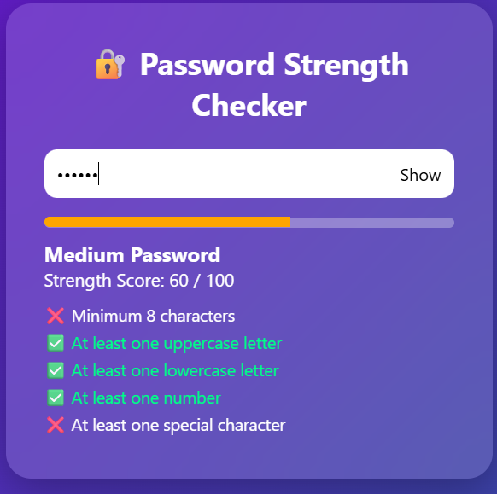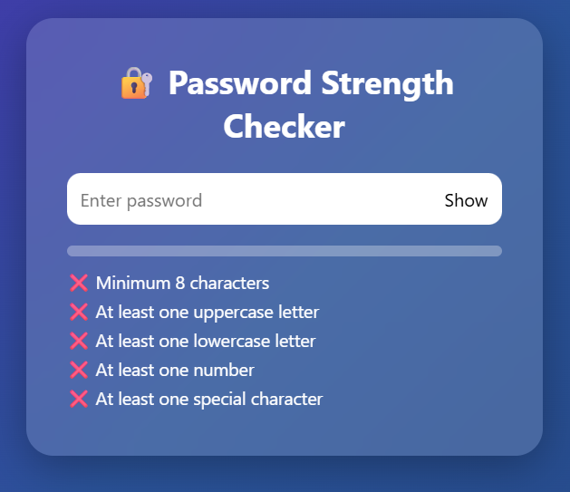

RESULT

The Password Strength Checker was successfully developed using HTML, CSS and JavaScript with Regex validation and real-time strength analysis.

CONCLUSION
Thus, the Password Strength Checker project was designed and implemented successfully. This project improved understanding of DOM manipulation, Regular Expressions and event handling in Web Technology

